## Student 1 Name: Michael Kelly

## Student 1 ID: s00153921

## Student 2 Name: Adam Lee

## Student 2 ID: s00174787

## Programme: Web Programming 3

## Submission Date: 10/11/16

Contents

[***Chapter 1*** Overview 2](#_Toc462923642)

[***Chapter 2*** Research 2](#_Toc462923643)

[2.1 Similar Systems 2](#_Toc462923644)

[2.2 Technologies 2](#_Toc462923645)

[***Chapter 3*** Design and User Interface 2](#_Toc462923646)

[3.1 User Interface 2](#_Toc462923647)

[3.2 Overall Architecture 2](#_Toc462923648)

[***Chapter 4*** Time Management 2](#_Toc462923649)

[***Chapter 5*** References 2](#_Toc462923650)

[***Chapter 6*** Appendices 2](#_Toc462923651)

# Overview

We want to design and build a website that will give our users a simple yet effective way to purchase tickets online, get directions to the venue and receive the latest news of the events and other information all in one website. We would like to offer our users the opportunity to create an account for purchasing tickets for events all over Ireland and keep track of the news coming up to these events. There will also be artist bios and news on upcoming events for all artists, also previous event details we maybe include a comments section so user who hold accounts with us can leave comments on the event if they attended and how their experience was at the event. We are aiming for a visual website but we aim to keep it simple for easy navigation and quick purchases.

# Research

## Similar Systems

**Ticketmaster-** Ticket sales, user ability to select favourites from a list of categories, login to the site to access their previous bought tickets and upcoming events that they might like.

**Tickes.ie-** The user will have the ability to search for music or browse through a page with categories, the user will also be able to do a search for tickets based on the person they are wishing to acquire tickets for.

**Ticketbooth-** The user will be able to browse through a gallery of images based on the selected event, the user will also be able to post reviews and view other reviews before buying a ticket.

**Ticketofficesales-** The user will be able to keep up to date with a news feed that will tell them if an event has been cancelled or there has been a time change.

## Technologies

**Bootstrap-** for the responsiveness of the site.

**Visual studio-** for the code editor, Database design and also the CSS design.

**Stripe-** this will be used for the payment methods.

**API-** This will be used for the newsfeed feature, there will also be a google map API which displays an interactive map, there will also be an api for the user login

If there is time left at the end we would like to include emails or SMS messages on the latest news.

# Design and User Interface

## User Interface

## 

## E:\Year 3\WebProgramming3\Assign1Document\IMG_0563.JPG

## E:\Year 3\WebProgramming3\Assign1Document\IMG_0564.JPG

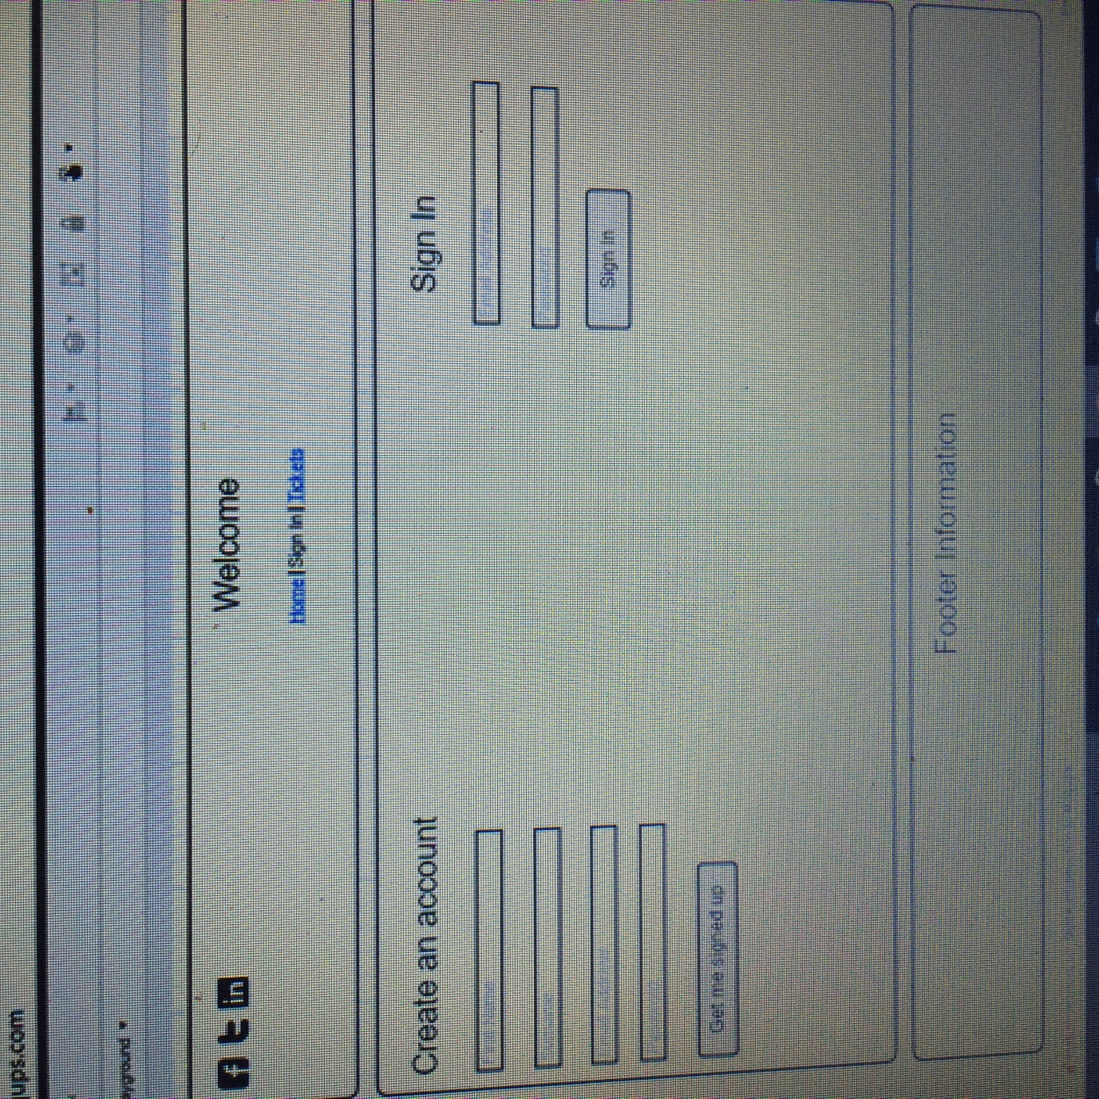

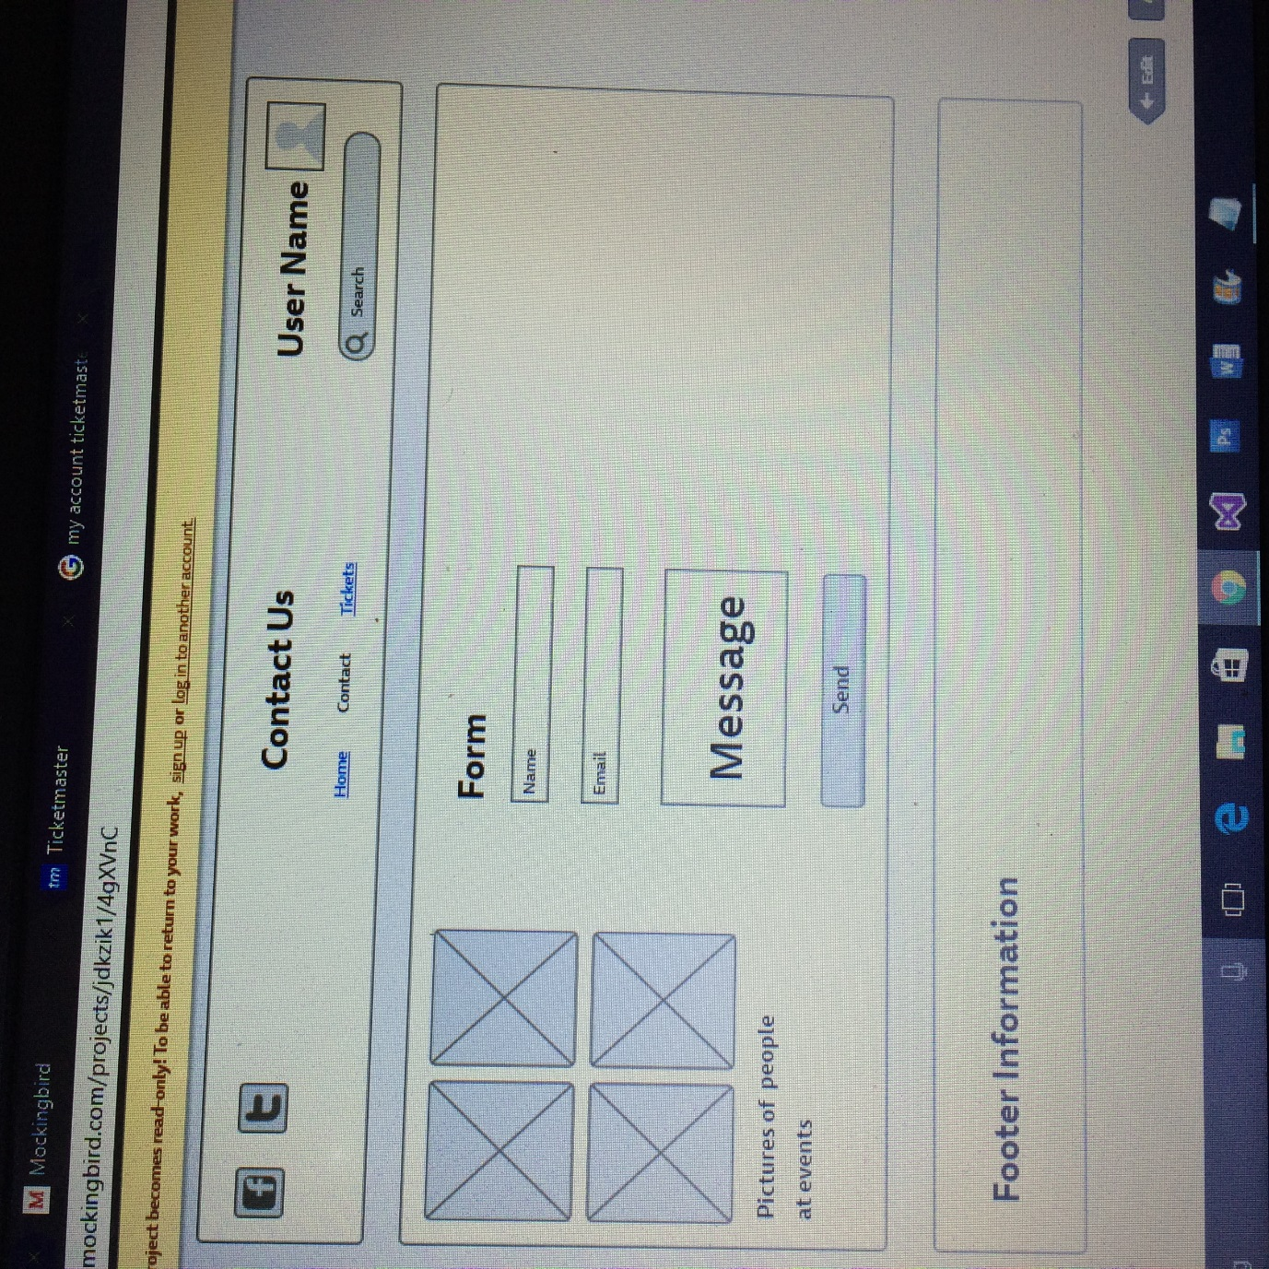

## Overall Architecture

C:\Users\adaml\AppData\Local\Microsoft\Windows\INetCacheContent.Word\Web3SiteMap.png

The site map above is the final version of the sitemap we have decided to stay with the design as it is simple, easy to navigate. If there is time towards the end of the project more pages may be added to give a more realistic view of what we would like the website to look like if we had more time for development. The webpages will include data pulled directly from the database and will update when tickets are sold out or new dates for events have been added etc.

## Database Design if applicable

C:\Users\adaml\AppData\Local\Microsoft\Windows\INetCacheContent.Word\Web3ERD.PNG

# Current Progress

## Week 1 - 3 Progress

* Week 1- We set up a meeting in the library and after brainstorming we came up with an idea to do a simple website that will allow users to purchase tickets online for events such as concerts, festivals, comedy show etc.
* Week 2- This week we started to come up with use cases for users to get some of the functionality out. (100%).
* Week 2- Completed the Entity Relationship diagram and the site map for the website.
* Week 2- We found a template for the site that has the design features we want to do.
* Week 3- We worked again on the use cases and added extra content to them just to expand the project.
* Week 3 – We found APIs which will help the projects functionality.

weeks 1-3. Indicate the % of each task completed >>

## Week 4 - 7 Progress

* We worked on the template and added more bootstrap to make it more responsive. (50%)
* Added the Registration so the user can sign up to book tickets. (100%)
* Added the login feature so the user can login to see upcoming events etc. (75%)
* Edited the templates code to fit around our wireframes. (40%)
* Created the database which will take in the details of the web form. (90%)

## Week 7- 12 Progress

* Integrating the database into the web forms. (18/11/16)
* Create the web forms upcoming events, previous events etc. (14/11/2016)
* Improve the overall appearance of the website. (13/11/16)
* Complete the database by writing queries to retrieve data from the database. (11/11/2016)
* Implement the APIs in the website. (25/11/16)
* Implement the Stripe payment method for users trying to purchase tickets. (25/11/16)
* Having a working demo of the site. (28/11/16)

# References

<<Not mandatory to include at this point.>>

# Appendices

<<Not mandatory to include at this point.>>